Lab Report 5

*Name: Sricharan Vinoth Kumar*

*Roll no: 2024112022*

*Group no: 10*

* Objective:

To assemble an Arithmetic Logic Unit and observe its working.

* Electronic Components Used:
  1. 74151 8 x 1 MUX IC
  2. 74157 Quad 2 x 1 MUX IC
  3. 7486 2 Input XOR Gate
* Reference Circuit:

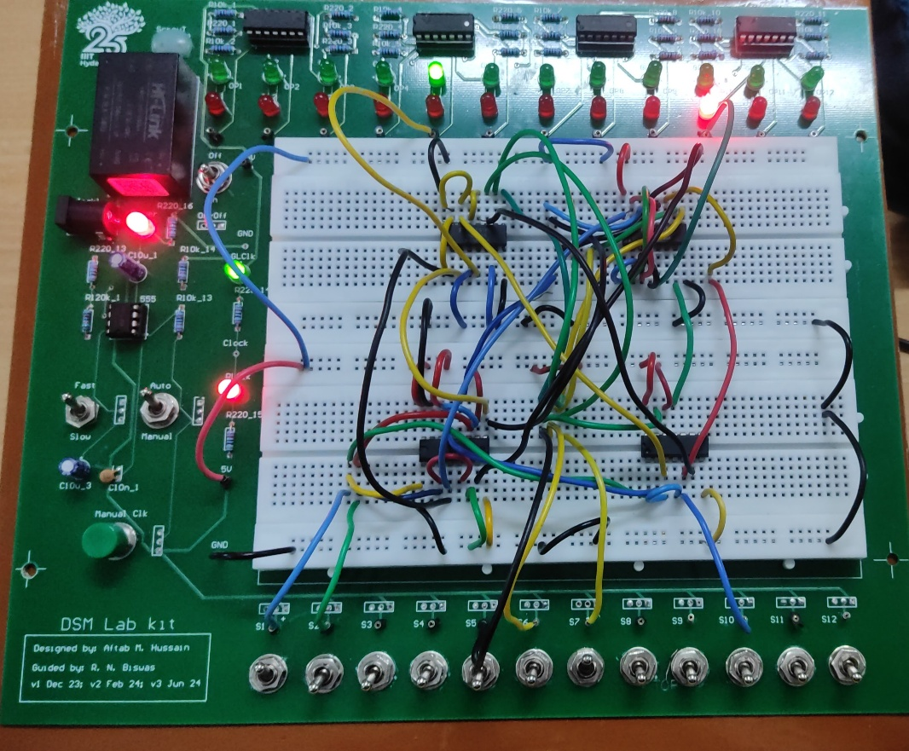

* Procedure:
  1. Ensure that the input pins IP1-12 and output LEDs LG1-12 and LR1-12 are working. Set the CLOCK of the kit in FAST mode.
  2. Obtain a Quad 2 x 1 Multiplexer IC, 1 2 input XOR IC and 2 8 x 1 Multiplexer ICs.
  3. Use the 2 x 1 Multiplexers to perform the operations (except XOR) on inputs A and B of the ALU. Use the XOR IC to perform the XOR operations
  4. Connect the outputs of the 2 x 1 Muxes and the XOR IC to the inputs of the 8 x 1 Muxes as shown in the circuit diagram.
  5. Designate 3 inputs F0, F1 and F2 to act as the function selectors. Connect them and the input C to the selection lines appropriately as per the circuit diagram.
  6. Connect the Enable pins of the MUX as shown in the diagram.
  7. Apply all possible combinations of function selector and inputs A, B, C and observe the outputs.
* Observation:

The function table of the assembled ALU is:

|  |  |  |  |
| --- | --- | --- | --- |
| **F1 F2 F3** | **ALU Function** | **Y1** | **Y0** |
| 000 | Zero | - | 0 |
| 001 | A OR B | - | A + B |
| 010 | A AND B | - | A . B |
| 011 | A EXOR B | - | A ⊕ B |
| 100 | A PLUS B | Carry | Sum |
| 101 | A MINUS B | Borrow | Difference |
| 110 | A PLUS B PLUS C | Carry | Sum |
| 111 | A MINUS B MINUS C | Borrow | Difference |

* Conclusion:

An Arithmetic Logic Unit has been successfully assembled and its operation has been observed.

* TinkerCAD Simulation:

<https://www.tinkercad.com/things/hK5vdrIUdVu-dsm-lab-5?sharecode=b5JtsilFGiYO9XW3vSoND3W9Nc0SsP8IM08hZef7RuM>